Test in AWS

{  "body": {  "action": "list"  }  } | 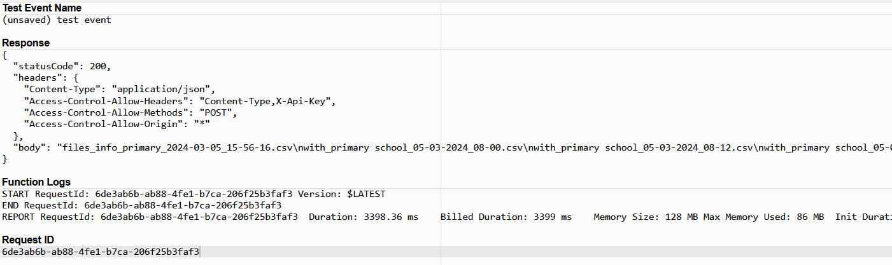
{  "body": {  "action": "parce",  "keyword": "primary"  }  } | 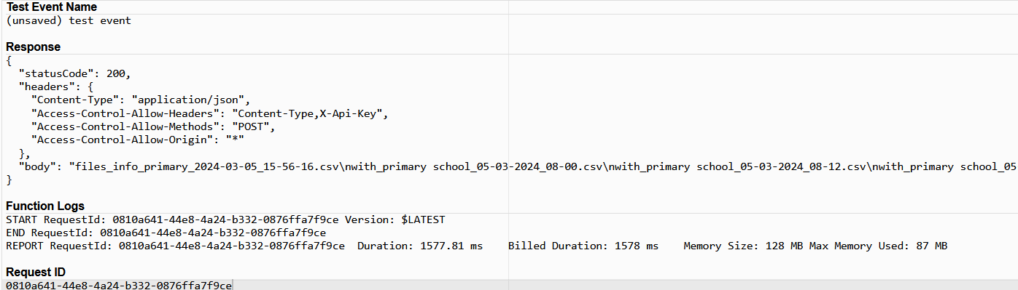
{  "body": {  "action": "show",  "file_name": "with_primary school_01-03-2024_08-41.csv"  }  } | 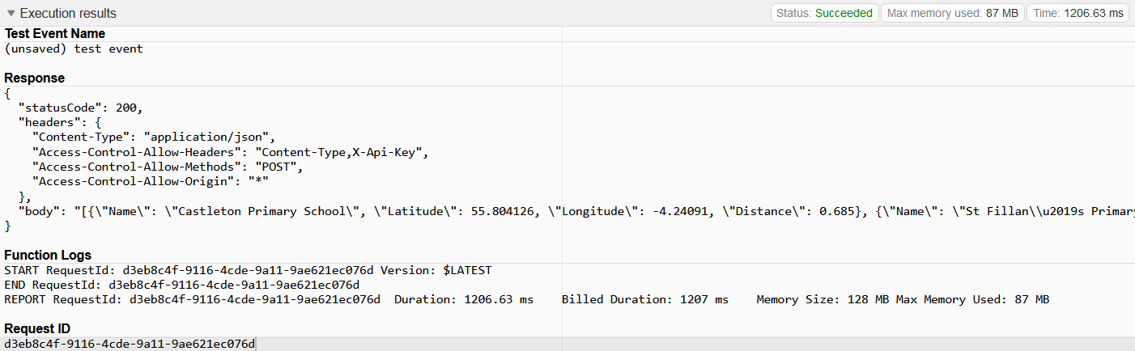
{  "body": {  "action": "delete",  "file_name": "without_primary school_01-03-2024_11-34.csv"  }  } | 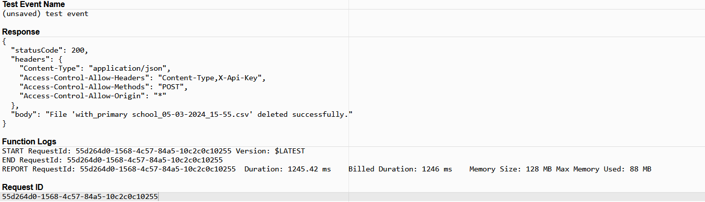
{  "body": {  "action": "delete by keyword",  "keyword": "castleton"  }  } | 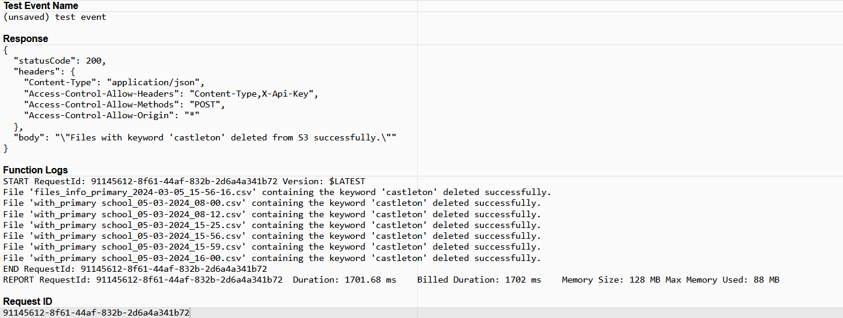
{  "body": {  "action": "save by keyword",  "keyword": "primary"  }  } | 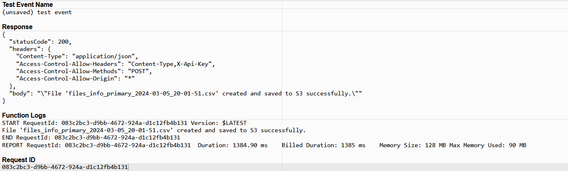
{  "body": {  "data": {  "lat": 55.802,  "lon": -4.2512,  "radius": 4000,  "place_type": "school",  "no_keyword": "Primary School"  }  }  } | 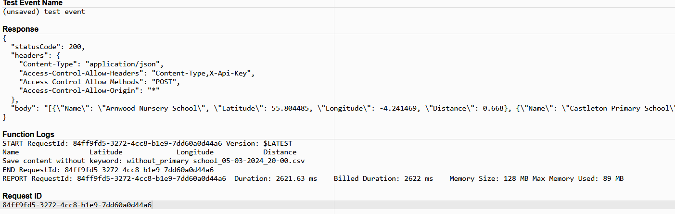
{  "body": {  "data": {  "lat": 55.802,  "lon": -4.2512,  "radius": 4000,  "place_type": "school",  "keyword": "Primary School"  }  }  } | 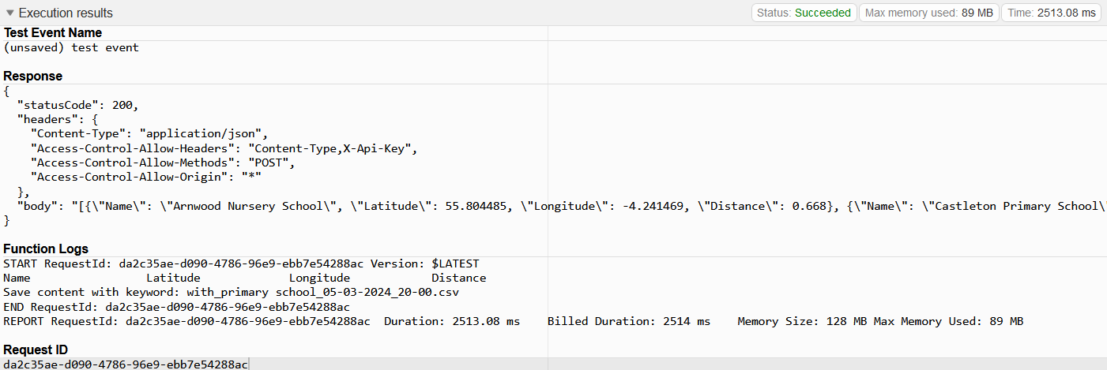
{  "body": {  "data": {  "lat": 55.802,  "lon": -4.2512,  "radius": 4000,  "place_type": "school"  }  }  } | 